**Tribhuvan University**

**Institute of Science and Technology**

**Himalaya College of Engineering**

A Final Year Report

On

**“Parking System using Automatic License**

**Plate Recognition”**

**Submitted by**

Abin Timilsina [24042/076]

Kritika Sharma [24053/076]

Ruza Kansakar [24067/076]

**Submitted to**

Department of Computer Science and Information Technology

In partial fulfillment of the requirements for the bachelor’s in computer science and information technology

# **Table of Contents**

Abstract ii

Acknowledgement iii

Table of Contents. iv

List of Tables. vi

List of Figures. vii

Chapter 1: Introduction. 1

1.1. Background. 1

1.2. Problem Statement 2

1.3. Objectives. 2

1.4. Limitations. 3

1.5. Scope. 3

Chapter 2: Literature Review.. 5

Chapter 3: Requirement Analysis. 7

3.1. Functional and Non- Functional requirements. 7

3.1.1. Functional requirements. 7

3.1.2. Non-functional requirements. 7

3.2. Use Case Diagram.. 9

3.3. Feasibility Study. 10

3.3.1. Economic Feasibility. 10

3.3.2. Operational Feasibility. 10

3.3.3. Technical Feasibility. 10

3.3.4. Project Planning and Scheduling. 11

3.4. Structure System Requirements. 13

3.4.1. Data Modeling. 13

3.4.2. Process Modeling. 14

Chapter 4: System Design. 15

4.1. Architectural Design. 15

4.2. Database Design. 16

4.3. Activity Diagram.. 17

Chapter 5: Implementation and Testing. 18

5.1. Implementation. 18

5.2. Tools. 18

5.2.1. Web Application Development Tool 18

5.2.2. Back-End Tools. 18

5.2.3. Other Tools. 18

5.3. Testing. 19

5.3.1. Unit testing. 19

Chapter 6: Conclusion and Recommendations. 26

6.1. Future Enhancements. 26

# **List of Tables**

Table 1: Test case for User registration. 19

Table 2: Test case for Business registration. 20

Table 3: Test case for User Login. 21

Table 4: Test case for Tracking package. 22

Table 5: Test case for Shipping Package. 23

Table 6: Test case for Payment Gateway. 24

# **List of Figures**

Figure 1: Use Case Diagram.. 9

Figure 2: Gnatt Chart 11

Figure 3: ER Diagram.. 13

Figure 4: Level-1 Data-Flow Diagram.. 14

Figure 5: Architectural Diagram.. 15

Figure 6: Database Diagram.. 16

Figure 7: Activity Diagram.. 17

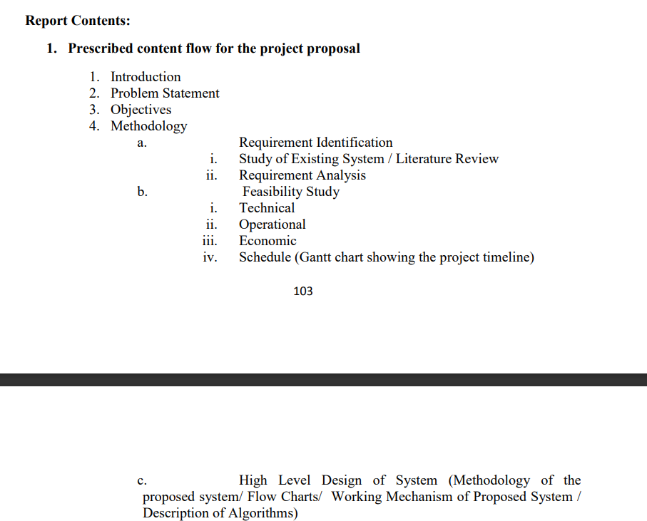

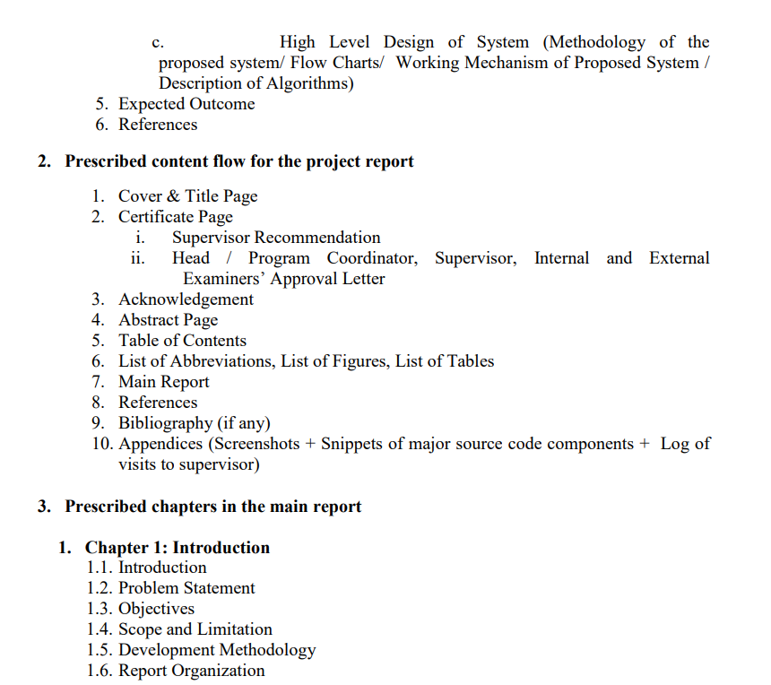

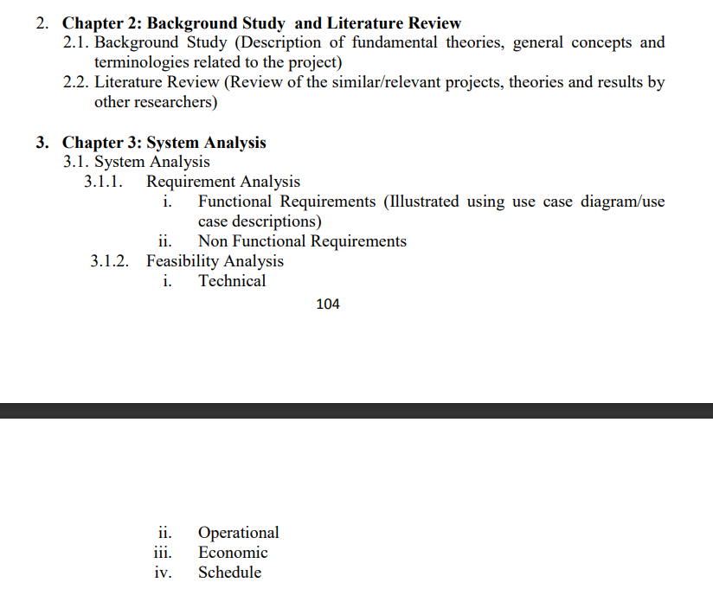

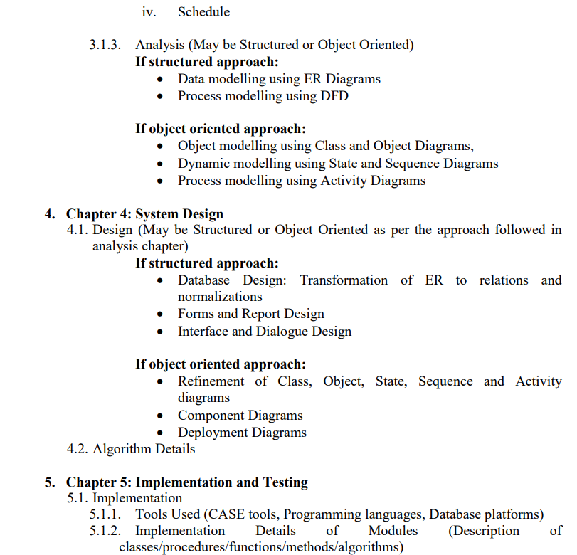

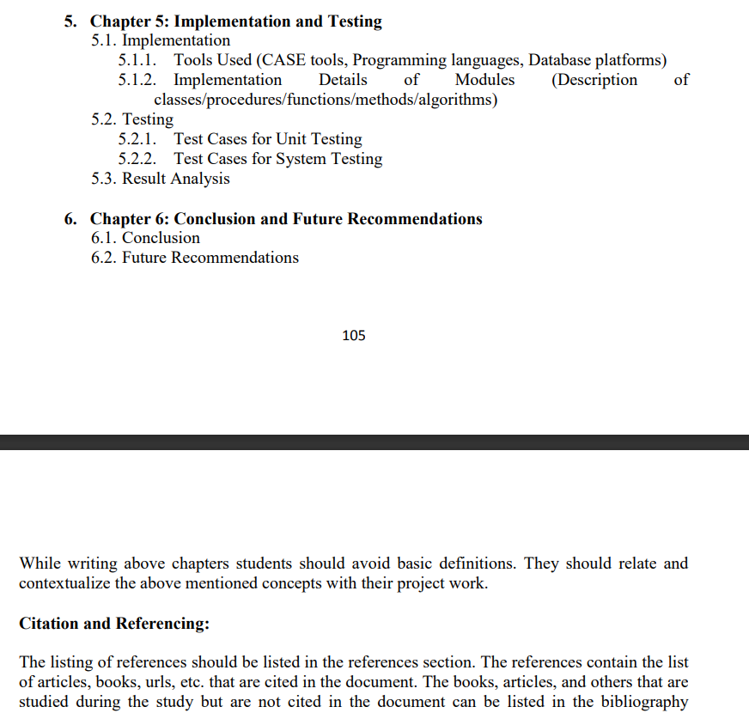

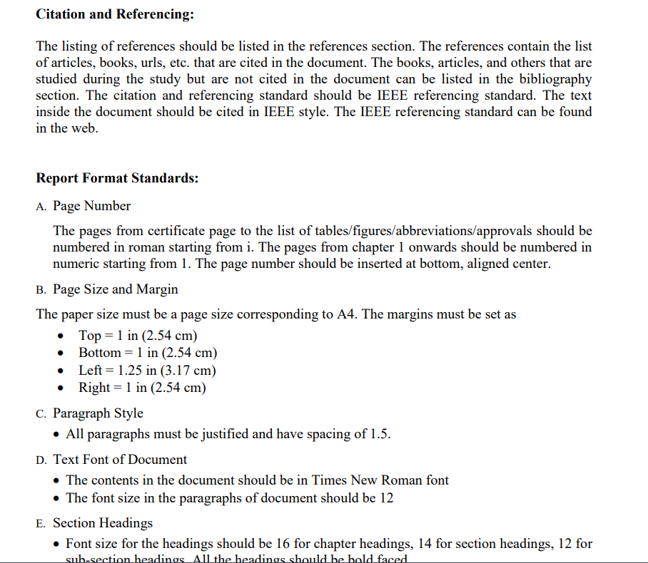

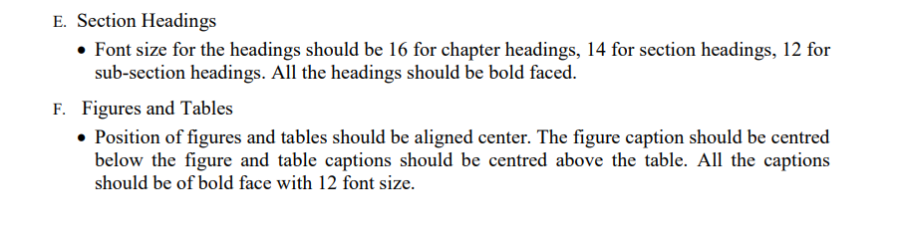

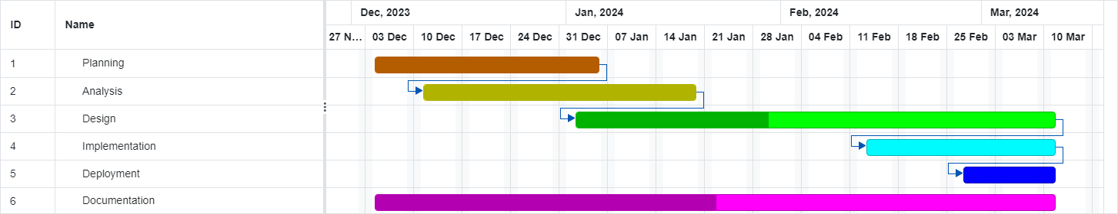

# 

# **Chapter 1: Introduction**

## **1.1.** **Introduction**

Automatic Number Plate Recognition (ANPR) technology has surged in popularity in recent years due to its wide range of benefits for various applications like traffic management, intelligent parking, toll automation, and surveillance. ANPR is a technique designed to read vehicle number plates without human intervention using high-speed image capture with supporting illumination, detection of characters within the images provided, verification of the character sequences as being those from a vehicle number plate, character recognition to convert image to text; so, ending up with a set of metadata that identifies an image containing a vehicle numberplate and the associated decoded text of that plate.

ANPR was first implemented in the 1990s and since then it has come a long way to become more efficient and cost-effective. These features have enabled large-scale implementation in law enforcement in several countries. However, ANPR still faces some challenges. Vehicle owners have used a variety of techniques in an attempt to evade ANPR systems and road-rule enforcement cameras in general. One method increases the reflective properties of the lettering and makes it more unlikely for the system to locate the plate or produce a high enough level of contrast to be able to read it. There are many difficulties that ANPR systems may face such as poor resolution, poor elimination conditions, blurry inputs, plate occlusion, different font sizes, and a variety of plate structures. Image acquisition is quite challenging from vehicle images due to the viewpoint change when vehicle bodies and license plates have similar color, multi-style plate formats, and non-uniform outdoor illumination conditions.

In this paper, we propose a Parking Solution leveraging Automatic Number Plate Recognition (ANPR) that integrates YOLO for object detection and CNN for Optical Character Recognition (OCR) to optimize parking management. As a vehicle approaches the entrance, a YOLO-equipped camera captures the license plate in real time, and the identified region is processed by a CNN for character recognition. The recognized plate information is cross-referenced with a user database for authentication, and if successful, the system allows the driver through. Vehicles with registered plates can automatically enter parking areas while non-registered vehicles will be charged extra at the time of check-in and check-out. The exit process involves automatic plate recognition, billing based on parking duration, and the opening of the exit gate upon payment confirmation. This ANPR solution enhances efficiency, security, and user experience, offering seamless and convenient parking processes. Privacy measures, scalability, and integration with other systems are essential considerations for successful implementation.

## **1.2.** **Problem Definition**

Traditional parking systems face a great number of challenges that impede their efficiency and user satisfaction. Primarily, reliance on manual ticketing and entry processes results in slow and error-prone operations, leading to long queues, delays, and increased labor costs. Moreover, these systems often lack robust security measures, leaving them vulnerable to unauthorized access and misuse. The absence of efficient authentication measures can contribute to security breaches and instances of unauthorized parking. Manual billing processes are prone to inaccuracies, creating potential disputes and revenue loss for parking facility operators.

Additionally, traditional systems may lack user-friendly features, such as mobile app integration or automated payment options, diminishing overall user convenience and satisfaction. Lastly, the environmental impact cannot be overlooked, as inefficient parking systems contribute to increased fuel consumption and emissions due to prolonged wait times, inefficient circulation within parking lots, and congestion around entry and exit points. The integration of modern technologies, as proposed in the solution incorporating ANPR, YOLO, and CNN, aims to address these challenges comprehensively by automating processes, enhancing security measures, and ultimately improving the overall user experience in parking facilities.

## **1.3.** **Objectives**

1. To implement an automated entry and exit system using YOLO-equipped cameras for automatic plate recognition, eliminating the need for manual ticketing, and streamlining the entry and exit process for vehicles in the parking facility.

2. To implement a time-based charging mechanism for registered vehicles during check-in and check-out and charge extra for non-registered vehicles.

3. To enhance user experience by reducing wait times and integrating user-friendly features such as mobile/web app access and automated payment options for seamless transactions.

## **1.4.** **Limitations**

While the proposed parking management system addresses many challenges in traditional parking systems, it also has certain limitations. Some of the potential limitations include:

1. Cost of Implementation: Integrating advanced technologies such as ANPR, YOLO, and CNN may involve significant upfront costs for hardware, software, and system integration. This could be a barrier for smaller parking facilities with limited budgets.

2. Limited Recognition Accuracy: While YOLO and CNN technologies are advanced, there may still be limitations in the recognition accuracy, especially under challenging conditions such as poor lighting, adverse weather, or obscured license plates.

3. Privacy Concerns: The use of ANPR raises privacy concerns, as the system involves capturing and processing vehicle license plate information. Ensuring compliance with privacy regulations and addressing public concerns about data security is essential.

4. Limited Coverage for Non-Standard Vehicles: The system may have limitations in recognizing license plates for non-standard vehicles, such as motorcycles or vehicles with unconventional plate placements, potentially excluding certain categories of users.

## **1.5.** **Report Organization**

# **Chapter 2: Literature Review**

**2.**

Automatic Number Plate Recognition (ANPR) has emerged as a critical technology in the field of intelligent transportation systems, offering efficient and accurate identification of vehicle license plates. This literature review delves into the integration of the YOLO (You Only Look Once) algorithm for object detection and Convolutional Neural Networks (CNN) for Optical Character Recognition (OCR) in ANPR systems, exploring the advancements, challenges, and applications in this domain.

The YOLO algorithm, introduced by Redmon et al. [1], revolutionized object detection by enabling real-time processing through a single neural network pass. Its speed and accuracy make it an attractive choice for ANPR applications, allowing swift identification of license plate regions in images or video frames. Research by Redmon and Farhadi [2] discusses YOLO's capabilities in real-time object detection and its potential for integration into surveillance and monitoring systems.

In the realm of ANPR, the integration of CNN for OCR further enhances the system's accuracy in recognizing characters on license plates. The study conducted by LeCun et al. [3] highlights the effectiveness of CNNs in image recognition tasks. Researchers have extended these principles to license plate character recognition, utilizing CNN's ability to learn hierarchical features and patterns [4]. The work of Chen et al. [5] demonstrates the successful application of CNN in ANPR, achieving robust character recognition even under challenging conditions.

The synergy between YOLO for object detection and CNN for OCR has been explored by several researchers to create robust ANPR systems. Li et al. [6] proposed a comprehensive ANPR system integrating YOLO for license plate localization and a CNN for character recognition, showcasing its effectiveness in real-world scenarios. The study emphasizes the importance of end-to-end training, allowing the system to jointly optimize object detection and character recognition.

Challenges in this integrated approach include the need for large and diverse datasets to train both YOLO and CNN components effectively. Training these models requires substantial computational resources, as discussed by Redmon et al. [7]. Additionally, issues such as variable lighting conditions and plate occlusions pose challenges that researchers aim to address [8].

In conclusion, the integration of YOLO for object detection and CNN for OCR in ANPR systems represents a significant advancement in intelligent transportation systems. The literature demonstrates the effectiveness of this approach in achieving real-time and accurate license plate recognition. Ongoing research focuses on overcoming challenges, paving the way for further improvements and widespread adoption of this integrated technology.

# **Chapter 3: Requirement Analysis**

**3.**

## **3.1.** **Functional and Non- Functional requirements**

**1.**

**2.**

**3.**

**3.1.**

### **3.1.1.** **Functional requirements**

· The camera should accurately detect vehicles approaching the entrance and capture the license plate in real time.

· The Convolution Neural Networks(CNN) should process the identified license plate region for character recognition and the OCR system must accurately extract and interpret the characters on license plate.

· The recognized plate information should be cross reference with the user database for authentication.

· Nonregistered vehicles should be charged extra based on the duration of parking calculated from checking to check out times.

· Billings should be performed based on the parking duration of vehicles.

· The exit gates should open payment confirmation.

### **3.1.2.** **Non-functional requirements**

· The system should operate in real time providing quick and accurate result for vehicle detection plate recognition and authentication.

· Implement robust security measures to protect the user database and prevent unauthorized access.

· Provide a seamless and user friendly experience for both registered and non-registered users to use the parking system.

## **3.2.** **Use Case Diagram**

**Figure 1: Use Case Diagram**

## **3.3.** **Feasibility Study**

**3.2.**

**3.3.**

### **3.3.1.** **Economic Feasibility**

### **3.3.2.** **Operational Feasibility**

### **3.3.3.** **Technical Feasibility**

### **3.3.4.** **Project Planning and Scheduling**

The work breakdown and time in week as well as days required to complete the project is shown below:

|  | Week 1-2 | Week 3-4 | Week 5-6 | Week 7-8 |
| --- | --- | --- | --- | --- |
| Planning |  |  |  |  |
| Project Design |  |  |  |  |
| Project Implementation |  |  |  |  |
| Deployment |  |  |  |  |
| Documentation |  |  |  |  |

**Figure 2: Gnatt Chart**

## **3.4.** **Structure System Requirements**

**3.4.**

### **3.4.1.** **Data Modeling**

**1.**

**2.**

**3.**

**3.1.**

**3.2.**

**3.3.**

**3.4.**

**3.4.1.**

#### ***3.4.1.1.*ER Diagram**

**Figure 3: ER Diagram**

### **3.4.2.** **Process Modeling**

**3.4.2.**

#### ***3.4.2.1.*Data flow Diagram (DFD)**

**Figure 4: Level-1 Data-Flow Diagram**

# **Chapter 4: System Design**

**4.**

## **4.1.** **Architectural Design**

**Figure 5: Architectural Diagram**

## **4.2.** **Database Design**

**Figure 6: Database Diagram**

## **4.3.** **Activity Diagram**

**Figure 7: Activity Diagram**

# **Chapter 5: Implementation and Testing**

**5.**

## **5.1.** **Implementation**

# **Chapter 6: Conclusion and Recommendations**

**6.**

## **6.1.** **Future Enhancements**

# **References**

[1]. J. Redmon, S. Divvala, R. Girshick, and A. Farhadi, "You Only Look Once: Unified, Real-Time Object Detection," in arXiv preprint arXiv:1506.02640, 2016.

[2]. J. Redmon and A. Farhadi, "YOLO9000: Better, Faster, Stronger," in Proceedings of the IEEE Conference on Computer Vision and Pattern Recognition, 2017, pp. 7263-7271.

[3]. Y. LeCun, L. Bottou, Y. Bengio, and P. Haffner, "Gradient-based learning applied to document recognition," in Proceedings of the IEEE, vol. 86, no. 11, pp. 2278-2324, 1998.

[4]. T. Chen, S. Jin, X. Sun, and X. Luo, "License Plate Recognition Using CNN and SVM," in 2018 IEEE 3rd Advanced Information Technology, Electronic and Automation Control Conference (IAEAC), 2018, pp. 2120-2124.

[5]. L. Li, J. Yang, Y. Wang, and S. Li, "Vehicle License Plate Recognition Algorithm Based on YOLO and CNN," in 2019 International Conference on Intelligent Transportation, Big Data & Smart City (ICITBS), 2019, pp. 188-191.

[6]. W. Li, Z. Zhang, and Z. Liu, "License plate recognition system based on YOLO and CNN," in 2019 International Conference on Computer Application and System Modeling (ICCASM), 2019, pp. 1-5.

[7]. J. Redmon, S. Divvala, R. Girshick, and A. Farhadi, "You Only Look Once: Unified, Real-Time Object Detection," in arXiv preprint arXiv:1506.02640, 2016.

[8]. A. Hussain, S. Irtaza, and W. Jeon, "License Plate Recognition and Vehicle Type Classification in Unconstrained Scenarios," in Sensors, vol. 20, no. 3, 2020, p. 890.